Weekly English Planning Focus Book: Whatever Next Hedgehogs Class - Reception w/b: 28.06.21
 | Morning sentence | Learning objective | Main teaching | Activity | Resources | Vocabulary
Monday | last week I…. | To ask questions about a story | Tap Tap box: images of planets – recap naming the planets in order  Listen to the story ‘Whatever Next’.  As you read, add actions, pretending you are the bear going to the moon.  The story starts with a question. Can you think of other questions? What words are usually used to start questions? | Individual/small group:  Write a question about the story  Enhanced provision:  - Build a rocket outside  - Act out the story. Which characters/props will you need?  - Make a list of equipment you might need if you were going to travel to the moon.  - Make a picnic to eat on the moon.  (in afternoon make moon buggies from last weeks plan) | large construction  boxes  colander  wellies (space boots)  play food. | journey  space  moon  colander  who  what  where  when  why
Tuesday | Baby Bear asked…. | To sequence a story | Tap Tap box: props needed for bear to travel – rocket, helmet, space boots  Sequence the images from the story. Add the text to the sequenced cards.  As you sequence the cards add actions. | individual/small groups:  sequence the story image cards  Enhanced provision:  - Build a rocket outside  - Act out the story. Which characters/props will you need?  - Make a list of equipment you might need if you were going to travel to the moon.  - Make a picnic to eat on the moon. | large construction  boxes  colander  wellies (space boots)  play food.  images to sequence | journey  space  moon  colander  beginning  middle  end
Wednesday | Baby Bear found…  (a rocket, a space helmet and a pair of space boots) | To retell a story orally | Tap Tap box: an empty cardboard box.  draw story map as retell images 1-4 of sequenced cards. Children use actions.  Use ‘adapted version’ of story and add ‘once upon a time’. | individual/small groups:  Children draw images and retell the story in their own words.  Enhanced provision:  - Build a rocket outside  - Act out the story. Which characters/props will you need?  - Make a list of equipment you might need if you were going to travel to the moon.  - Make a picnic to eat on the moon. | cardboard box 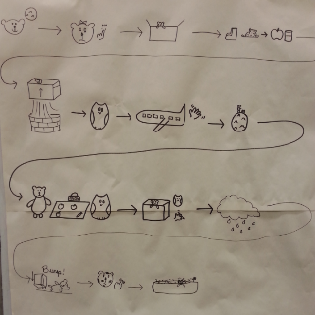 | journey  space  moon  colander  so  next  then  after that
Thursday | Baby Bear packed… | To retell a story using a story map | Tap Tap Box:  Retell beginning of story using actions and story map (and adapted text) from yesterday.  Add to the story map | Baby Bear made his rocket from a box. What would he need in order to build a real rocket?  Watch this video about spaceships:  https://www.youtube.com/watch?v=2R8V68viXqk  Draw and label your own diagram of a rocket to help Baby Bear. Make sure to label these parts:  Nose cone  Fin  Window  Body tube  Thrust | 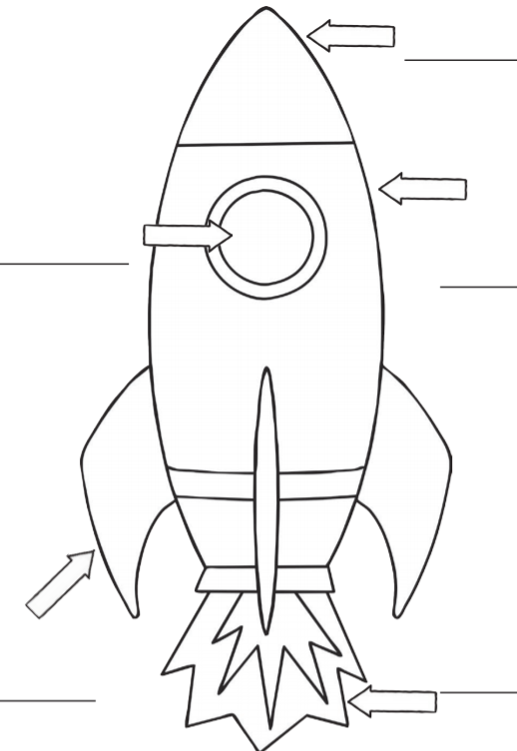  Workbook, pencils, colouring pencils | Diagram  Label  Nose cone  Fin  Window  Body tube  Thrust
Friday | On the moon Baby Bear said… | To retell a story using a story map | Tap Tap Box:  Retell beginning/middle of story using actions and story map (and adapted text) from yesterday.  Add to the story map | Baby Bear thinks that the moon is a bit boring. Plan some games and activities that he could do to make his trip a little more exciting.  You could design:  A card game  A dice game  A game involving outdoor equipment (hoops, hurdles, balls etc.)  A construction game - with small pieces, like Lego or Duplo, or large pieces like plastic bricks.  Draw your game, label it, then build it. | leggo, dice, cards, duplo, plastic bricks, wooden blocks, hoops, balls etc. | Game  Bored  Entertain  Design

