Weekly English Planning Focus Book: The Very Hungry Caterpillar Hedgehogs Class - Reception w/b: 24.05.21
 | Morning sentence | Learning objective | Main teaching | Activity | Resources | Vocabulary
Monday | In the light of the moon a little egg lay on a leaf | to segment and write the sounds in words  To write a sentence independently | Tap Tap box: ingredients for cakes  Model writing the sentence to continue the story. Draw attention to repeated refrain and Every time we write.  In the light of the moon a little egg lay on a leaf  One Sunday morning the warm sun came up  Suddenly Out of the egg came a tiny and very hungry caterpillar | LW - front row (+ others if time)  - Write beginning of story.  LWy middle row (+others) Make cupcakes ready to decorate in PM 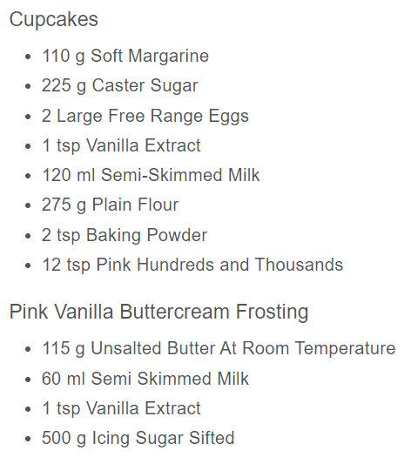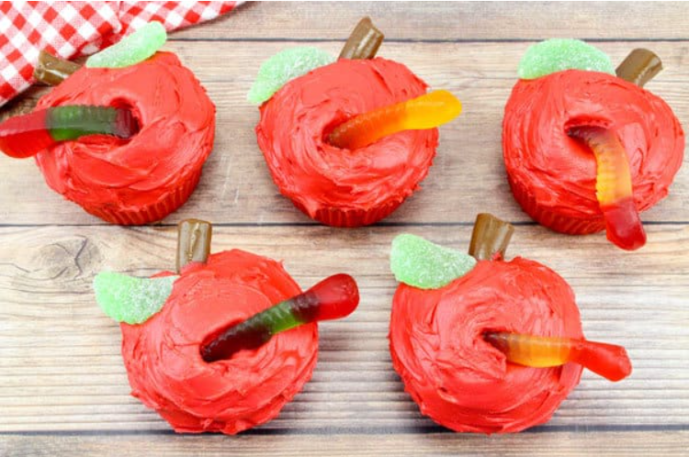  SN – back row Make collage. First print leaf background then use leaves to make a caterpillar  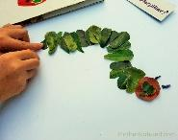  BF- continuous provision  - playdough | ingredients and recipe  leaves  paint | caterpillar  suddenly  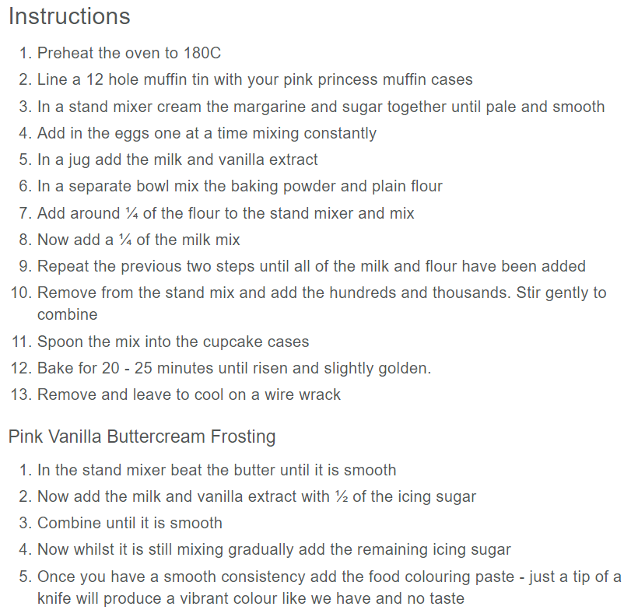
Tuesday | On Monday he ate through one apple but he was still hungry  On Tuesday he ate through two pears but he was still hungry | to segment and write the sounds in words  To write a sentence independently | Tap Tap box: example prints from yesterday  Model writing the sentence to continue the story. Draw attention to repeated refrain and Every time we write.  On Monday he ate through 1 apple but he was still hungry On Tuesday he ate through two pears but he was still hungry  On Wednesday he ate through three plums but he was still hungry On Thursday he ate through 4 strawberries but he was still hungry On Friday he ate through 5 oranges | LW – middle row (+ others if time)  - Write middle of story  LWy back row- printing fruit in order of The Very Hungry Caterpillar – apple, pear, plum, strawberry, orange  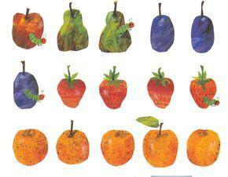  SN front row - Make collage. First print leaf background then use leaves to make a caterpillar  BF- continuous provision (phonics 1:1)  - playdough | fruit from story  paint | through  but  hungry
Wednesday | On Saturday he ate through one piece of chocolate cake | to segment and write the sounds in words  To write a sentence independently | Tap Tap box: example of child’s writing  Model writing the sentence to continue the story. Draw attention to repeated refrain and Every time we write.  On Saturday he ate through one piece of choc cake, one ice-cream cone, one pickle, one slice of swiss cheese, one slice of salami, one lollipop, one piece of cherry pie, one sausage, one cupcake and one slice of watermelon.  Then he had a stomach ache | HC – back row (+others – BF can take children 1:1) write next part to story, children write their own words but some verbal prompt if needed.  LWy front row- printing fruit in order of The Very Hungry Caterpillar – apple, pear, plum, strawberry, orange  SN – middle row  Make collage. First print leaf background then use leaves to make a caterpillar  BF continuous provision  - playdough | fruit from story  paint  leaf | stomach ache
Thursday |  | to segment and write the sounds in words  To write a sentence independently | Tap Tap Box: examples of work from yesterday.  Crawly caterpillar (Here’s one I made earlier!).  Model writing the sentence to continue the story. Draw attention to repeated refrain and Every time we write  Next was Sunday again. The caterpillar ate through one nice green leaf.  After that he felt much better  Now he was a big, fat caterpillar | ZA – work with children to continue story  (+BF can work 1:1 with children)  LWy - Middle Row  Make 2D cocoons out of carboard and hang them from a branch.  SN - make crawling caterpillars out of 1 pipe cleaner and two sticks (one attached to each end). Move the front end, then the back to make the caterpillar crawl along.  BF- continuous provision (phonics 1:1)  - playdough - build a caterpillar. | Cardboard, brown paint, thread.  Pipe cleaners, sticks (e.g. lollipop sticks), glue gun. | through, nice, leaf, much
Friday |  | to segment and write the sounds in words  To write a sentence independently | Tap Tap Box: Masks to be used in play version of story  Model writing the sentence to continue the story. Draw attention to repeated refrain and Every time we write  Finally he built a cocoon and stayed inside for 2 weeks  Then he was a beautiful butterfly | ZA – work with children to finish story  Class retelling of the story - children are the items of food, one child is caterpillar, another is a butterfly. Children not performing are the audience/storytellers.  BF- continuous provision (phonics 1:1)  - playdough - build a caterpillar | Masks - butterfly, caterpillar, foods | cocoon, inside, beautiful, butterfly

