Weekly extra activities Planning Hedgehog Class - Reception w/b: .21
 | Learning objective | Main teaching | Activity | Resources | Vocabulary
Exploring and using media and materials | Create a photograph story sequence | Please see page 10 of the Mouse’s Adventures booklet that we have been using in English (and re-read the story if you can’t remember it). Now it’s your turn - photograph one of your toys doing different things around the house, just like the mouse on page 10. Keep the photographs - you are going to need them for some English work later this week. Make the activities as fun and as funny as you can!  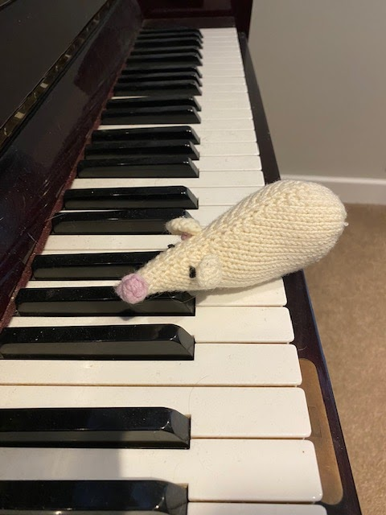 | Photograph your toy in at least 4 different places/doing 4 different things. | Camera phone/ipad etc to take photographs | Photograph, locations, activities
Understanding the world | Go on a colour green treasure hunt | Today, we are looking closely at the outdoors environment and identifying things which are green. This is a lovely activity for this time of year, when new green shoots are just starting to appear!   | Time to go out into your garden and/or for a walk. You are going on a treasure hunt! See how many of the green (or part-green) items from page 19 of the Mouse’s Adventures booklet you can find! What other green objects can you see? | Treasure hunt list on page 19 of the booklet. | Treasure hunt, green
Shape, space and measure | Slice fruit into small pieces, attach to a larger object, create a new semi-domed object | Please see pages 16-17 of the Mouse’s Adventures booklet. Your challenge is to make a fruit hedgehog! You need to slice fruit into small pieces (do NOT try this by yourself as knives can be dangerous - get an adult to help you) then attach them to a potato to make your hedgehog.  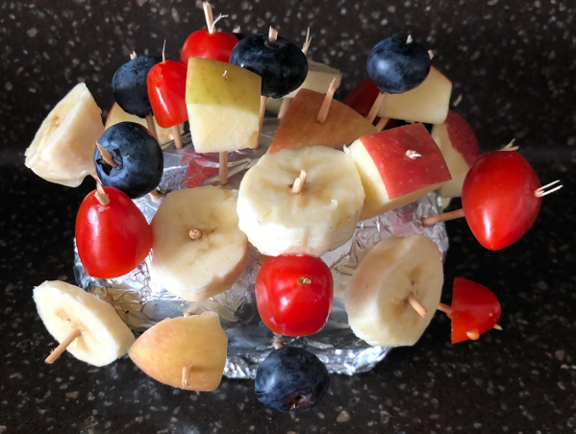 | Please see pages 16 and 17 for full instructions. | Fruit (you don’t have to just use the ones listed in the booklet - use whatever you want), potato, tin foil, cocktail sticks. | Slice, piece, stick, attach
PSHE | Use different body movements to imitate animals | Move your body in different ways to imitate different creatures. You could curl-up small and scuttle to be a mouse; flap your arms and move around smoothly like a flying bird; crouch down low then jump like a frog; make a long trunk with your arm and lumber like an elephant.  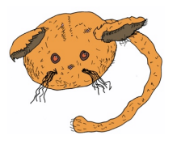 | Imagine that you are Mouse and you are going on an adventure. Where could you go in your house if you were a little mouse? Now, curl-up very small and see if you can scuttle like a mouse. Can you fit into small spaces, just like Mouse does? Now choose a larger creature - what is your favourite? How does it move? Pretend to be an animal and, without you telling them what it is, see if someone at home can guess. Then ask them to take a turn and you guess which creature they are impersonating. | Room to move! | Imitate, creature, small, scuttle, crawl, flap, lumber, guess
Music | Develop Makaton signing/lyric learning;  Practise counting songs. | As it won’t be long until we are reunited as a class, I want to wait a couple of weeks before we begin another sing/sign. We will practise Roar today, and some counting songs!  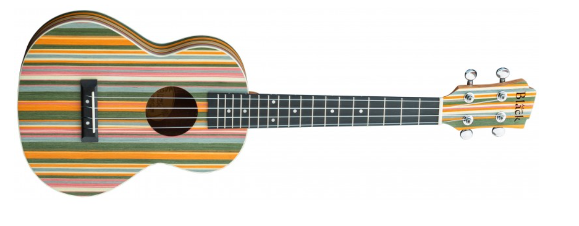 | Singing and Makaton signing, playing musical instruments whilst counting. | Please bring your instruments and big, loud singing voices! | Counting -1-10, 10-1, chanting.

