L.O. to learn about Guru Nanak
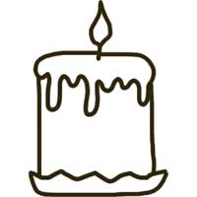
In the candle describe what Guru
Nanak was like.

In this candle describe what you are like.

