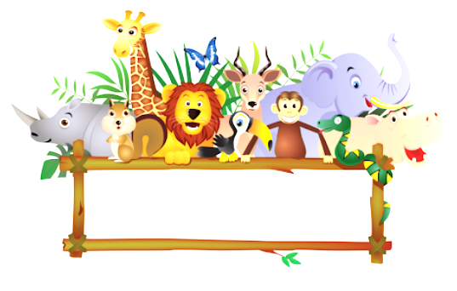
On Safari

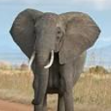
Safari is a Swahili word. Swahili is spoken in lots of African countries, such as Uganda, Tanzania and Kenya.
The word safari means journey. A safari is a trip to watch or hunt animals in their habitat. Lots of people go on safari holidays in East Africa.
On safari in Africa, you can see lots of animals.
Elephant
The African elephant is the world’s biggest land mammal. They can be 3 metres high and live up to 70 years.

Lion
Lions live in groups of up to 30 called prides. They are carnivores so hunt and eat other animals.

Giraffe
Giraffes are the tallest mammals. They have long legs and necks so they can eat the highest leaves on the trees.
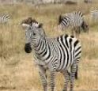
Zebra
Zebras live in herds and eat grass. They have black and white stripes which help to hide them in long grass.

Questions
1. Where does the word safari come from?
2. What does the word safari mean?
3. Where can you go on safari?
4. Name two animals you can see on safari.
5. How tall can an African elephant be?
6. What do lions eat?
7. Why do giraffes have long necks?
8. What do zebras eat?
9. Would you like to go on safari? Why?

----------------------------------------------------------------------------------------------

Questions
1. Where does the word safari come from?
2. What does the word safari mean?
3. Where can you go on safari?
4. Name two animals you can see on safari.
5. How tall can an African elephant be?
6. What do lions eat?
7. Why do giraffes have long necks?
8. What do zebras eat?
9. Would you like to go on safari? Why?

