Genre and text: Non-chronological Reports (non-fiction) Bees Class - Year 3 and 4 w/b: 07.06.2021
 | Learning objective | Main teaching | Activity | Resources | Vocabulary
Monday | LO: to find out information about a new species. | Our new unit for this half term is non-chronological reports (NCRs) – these tell us useful information about a subject.  A new species of animal has recently been discovered – the Crocky-wock. Come up with 3 questions you would like to know about the Crocky-wock – write these in your exercise book. | Create an imaginary animal of your own choosing.  Firstly, sketch your imaginary animal. Secondly, spend some time adding information to the animal – what does it eat, where does it live, how does it move, etc. | Exercise book, pencil, colouring pencils. | Non-chronological report, information, subject, imaginary animal, questions.
Tuesday | LO: to know the features of NCRs. | Look at the range of NCRs for this lesson – can you see any similarities in them?  Read the model NCR all about the Crocky-wock. Did you find the answers to your questions from yesterday’s lesson? | Using your copy of the Crocky-wock NCR, can you find and highlight the following features? Heading/title, introduction, sub-headings, topic/technical words, diagrams/picture/caption, factual adjectives, connectives, did you know? boxes, conclusion and present tense verbs. | Range of NCRs, The Crocky-wock NCR, features sheet, exercise book, pencil. | Non-chronological report, information, features, heading, sub-heading, introduction, conclusion.
Wednesday | LO: to retrieve information from a NCR. | We are going to create a mini-quiz all about the Crocky-wock.  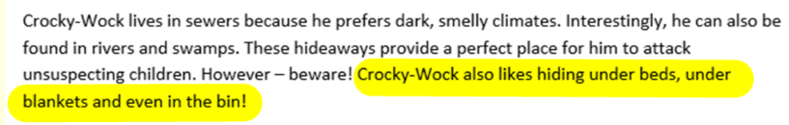  Scan the Crocky-wock NCR to find an interesting fact, e.g.  If this was the answer, the question would be:  Q: Where does the Crocky-wock like hiding?  A: The Crocky-wock likes hiding under beds, under blankets and in the bin. | Use the template below to create a quiz question using the Crocky-wock NCR: 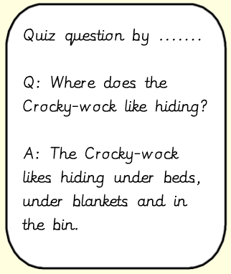  Try to use question starters such as who, what, when, where, why, how and if. | The Crocky-wock NCR, exercise book, pencil. | Non-chronological report, quiz, fact, question, answer, who, what, when, where, why, how, if.

