Genre and text: Explanation texts (non-fiction) Bees Class - Year 3 and 4 w/b: 19.04.2021
 | Learning objective | Main teaching | Activity | Resources | Vocabulary
Monday | LO: to know when to use a new paragraph. | Paragraphs are a group of sentences written about the same idea or topic.  To know when to use a new paragraph, we use:  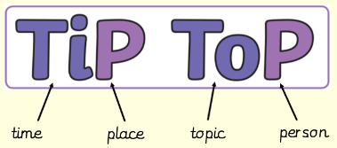  Use the SMART notebook slides to show examples of each of these changes for a new paragraph.  Use the plants explanation text to find where the author has shown a change of place, topic or time. | Use either the explanation text on:  - Frog life cycle  - Butterfly life cycle  - Water cycle  Separate this explanation text into paragraph – when there is a change in time, topic or place.  Cut each paragraph out and stick this in your exercise book. | SMART notebook slides, plants explanation text, frog life cycle text, butterfly life cycle text, water cycle text, exercise book, pencil. | Explanation text, paragraphs, change in…, time, place, person, topic.
Tuesday | LO: to identify causal conjunctions and use them effectively. | A causal conjunction is the joining word used to show cause and effect, e.g. today it is snowing, consequently I made a snowman.  Look at the example in the model text – ‘because of this’. New rock is formed because sediment is compressed.  Use the examples on the slide to decide which pictures go together. Can you make up a sentence using a causal conjunction for them? | Use the picture cards to create a sentence using a causal conjunction, then write them in your exercise book.  Challenge: can you make your own sentence using a causal conjunction? | SMART notebook slides, picture cards, exercise book, pencil. | Causal conjunction, cause, effect, because, since, so, yet, consequently, as a result.
Wednesday | LO: to use the present perfect tense. | Explanation texts are written in the present perfect tense.  We can break down the present perfect tense:  Subject + has / have + past form of the verb, e.g. I have eaten snails, I have lived in Paris, etc.  We can also change the present perfect tense into a question. E.g. You have wondered about how fossils are formed Have you ever wondered about how fossils are formed? | 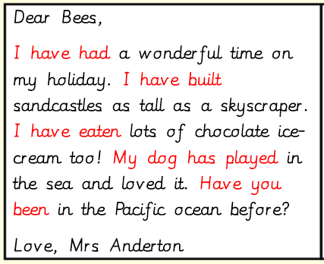  Write a postcard from an imaginary holiday. When writing this postcard, use the present perfect tense, e.g. | Exercise book, pencil. | Present perfect tense, have / has, past form of the verb, subject.

