Weekly Maths Planning Unit: Division Bees Class - Year 3 and 4 w/b: 08.03.2021
 | Learning objective | Main teaching | Activity | Resources | Vocabulary
Monday | LO: to divide using equal grouping. | Watch this video:  https://vimeo.com/489844871 | Complete the ‘divide 2-digits by 1-digit – part 1’ worksheet in your exercise book. | Video link, worksheet, exercise book, pencil. | Division, divide, share, equal groups, dividend, divisor, quotient, part-whole model.
Tuesday | LO: to divide using the part-whole model. | Watch this video:  https://vimeo.com/489845622 | Complete the ‘divide 2-digits by 1-digit – part 2’ worksheet in your exercise book. | Video link, worksheet, exercise book, pencil. | Division, divide, share, equal groups, dividend, divisor, quotient, part-whole model.
Wednesday | LO: to divide 100 into 2, 4, 5 and 10 equal parts. | Watch this video:  https://vimeo.com/489848691 | Create your own dividing by 100 shape puzzle:  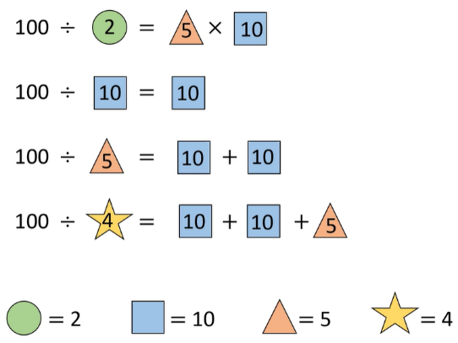  Make up your own dividing by 100 number sentences then replace your divisor and quotients with different shapes. | Video link, exercise book, pencil. | Division, divide, remainders, share, equal groups, dividend, divisor, quotient.

