Weekly Maths Planning Unit: Fractions Bees Class - Year 3 and 4 w/b: 17.05.2021
 | Learning objective | Main teaching | Activity | Resources | Vocabulary
Monday | LO: to find fractions of amounts. | 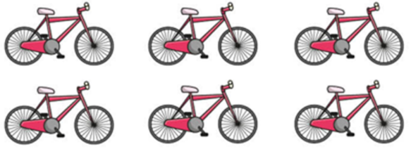  Use this representation to work out 1/3 of this amount.  Firstly, find the whole (9). We are working out 1/3 of 9. We are sharing 9 into 3 groups and finding one of these groups, e.g. 9 ÷ 3 = 3.  Y4: what is 2/3 of 9 – this time we are sharing 9 into 3 groups and finding 2 of these groups, e.g. 9 ÷ 3 = 3 / 3 x 2 = 6.  Repeat with other examples using the SMART notebook slides. | Complete the relevant worksheet questions for the year group. | SMART notebook slides, exercise book, pencil, worksheet questions. | Fractions of amounts, numerator, denominator, part, whole, share.
Tuesday | LO: to subtract fractions. | 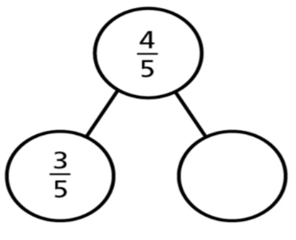  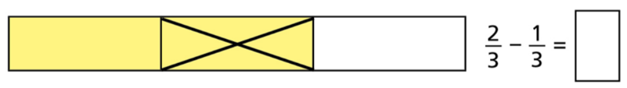  Use a bar model representation to show how to subtract fractions – the numerator changes but the denominator does not.  This can also be represented as a part whole model. Ensure children are looking at which is the whole and which are the parts. | Complete the relevant worksheet questions for the year group. | SMART notebook slides, exercise book, pencil, worksheet questions. | Subtract, take away, bar model, part-whole model, whole, parts, numerator, denominator.
Wednesday | LO: to find equivalent fractions. | Fractions can have different numbers but the same value – these are equivalent fractions, e.g. ½ and 2/4.  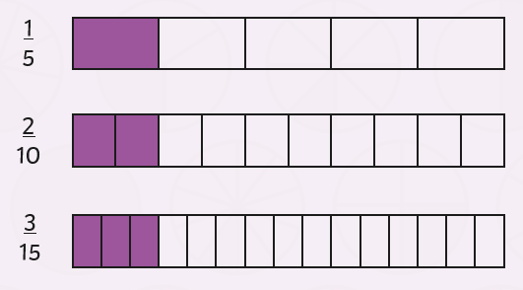  Use a fraction wall to show how to find equivalent fractions. Do you notice a pattern?  Encourage children to use their times table knowledge to change both the numerator and the denominator. | Complete the relevant worksheet questions for the year group. | SMART notebook slides, exercise book, pencil. | Equivalent, same, numerator, denominator, different numbers / same value.

