Wider Curriculum Planning Bees Class w/b: 07.06.2021
 | Learning objective | Main teaching | Activity | Resources | Vocabulary
Science | LO: to explore animal skeletons. | Lots of animals have their skeletons inside their bodies. We call these endoskeletons.  Some animals have skeletons on the outside of their bodies. These are called exoskeletons.  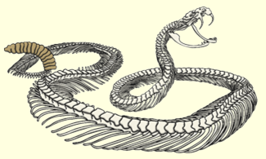  A snake has over 300 vertebrates. They have a rib attached to each vertebrate. This helps them to be flexible and slither along the ground. | - Use the animal skeletons to sort them in different ways. How did you sort them?  - Match the animal skeleton to the correct animal.  - Choose one of these animals and explain the function (job) of this animal’s skeleton. | Animal skeletons to sort, animal skeleton matching sheet, exercise book, pencil. | Skeleton, endoskeleton, exoskeleton, function of the skeleton.
French | LO: to become familiar with the ‘Cher Zoo’ story. | Using the PowerPoint slides, read through the story of ‘Dear Zoo – Cher Zoo’. Could you find an English version of this book on the Internet to help you translate each slide? | How well do you know the story?  - In French, how was the monkey described? What does this mean in English?  - What does the word ‘écrit’ mean in this sentence? J’ai écrit au zoo pour obtenir un animal.  - Translate this to English - Il était parfait! | PowerPoint – Cher Zoo story, exercise book, pencil. | Cher Zoo, ecrit, envoye, gros, renvoye, grande, feroce, mechant, parfait.
RE | LO: tbc
Music | LO: to know what an ostinato is. | Follow the Oak Academy music lesson:  https://classroom.thenational.academy/lessons/rhythmic-ostinati-71j62d?activity=video&step=1 | Compose and notate your own rhythmic ostinato using the notation example.  Copy the simple score onto a piece of paper and write out the notation. | Music lesson link, ostinato score sheet, pencil. | Ostinato, repeating pattern, notes, notation, score.

