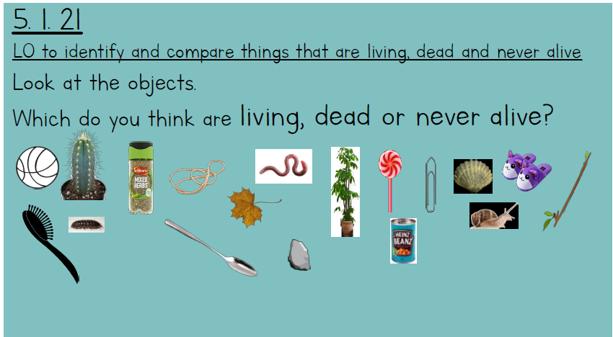

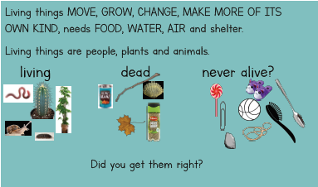

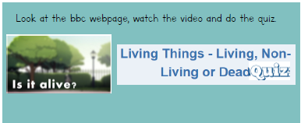
Go to webpage: https://www.bbc.co.uk/bitesize/topics/z6882hv/articles/zs73r82

Have a go at the Quiz at: https://www.educationquizzes.com/ks1/science/living-things-living-non-living-or-dead/
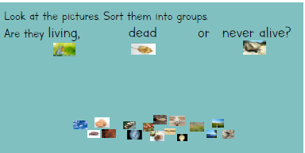
Cut out the pictures on the pupil sheet and stick them in the correct columns on the pupil chart sheet.

