Weekly Maths Planning Unit: Fractions Year 6 w/b: 7.12.2020
 | Learning objective | Main teaching | Activity | Resources | Vocabulary
Monday | To multiply fractions by integers | ⅓ x 2 = ⅔ ¼ x 3 = ¾  When multiplying fractions by integers, multiply the numerator by the integers and keep the denominator the same.  This is because the integer 3, for example, is the same as 3/1. SO if we are multiplying ⅓ x 2 we are actually multiplying ⅓ by 2/1. First, multiply the numerators: 1x2, then multiply the denominators: 3x1. Therefore ⅓ x 2/1 = ⅔  Watch video: https://vimeo.com/475426110 | Complete Monday worksheet | Video  Worksheet | Numerator  Denominator  Multiply
Tuesday | To multiply fractions by fractions | ⅓ x ½ = ⅙  Numerator x numerator  Denominator x denominator  Watch video: https://vimeo.com/476253821 | Roll a dice to create multiplication problems to solve. E.G. roll a dice to get a numerator and denominator for the first fraction, and same again for the second fraction. Then multiply them together.  When you have completed 5x your own multiplication problems solve:  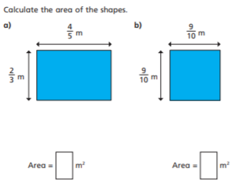 | Video  Dice
Wednesday | To divide fractions by integers | Watch video: https://vimeo.com/476254074  ⅓ ÷ 2 = ⅙ -> ⅓ x ½ = ⅙  We have flipped the integer (2 = 2/1 so flipped = ½ ) and multiplied the fractions together. | Complete page one of Wednesday/ Thursday worksheet | Video  Worksheet
Thursday | To divide fractions by integers | Watch video: https://vimeo.com/480707655 | Complete page two Wednesday/Thursday worksheet | Video  Worksheet
Friday | Fraction investigation | https://nrich.maths.org/1103 |  |  | Numerator  Denominator

